VRI BESTILLINGS KATALOG

STAY AUTHENTIC BENCH JACKET
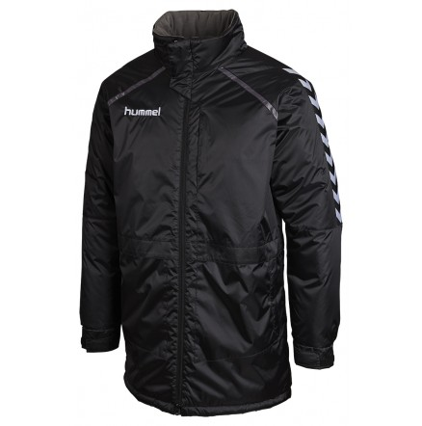
80- 378 - 2001
STR | ANTAL
6/8
10/12
14/16
S
M
L
XL
XXL

STAY AUTHENTIC BENCH JACKET
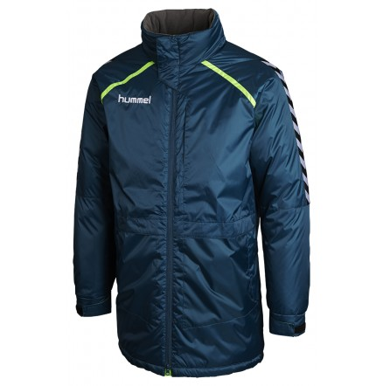
80 – 378 - 7511
STR | ANTAL
6/8
10/12
14/16
S
M
L
XL
XXL

STAY AUTHENTIC ALL WEATHER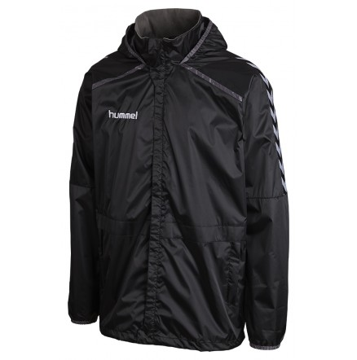
80 – 377 2001
STR | ANTAL
6/8
10/12
14/16
S
M
L
XL
XXL
MED HÆTTE

STAY AUTHENTIC ALL WEATHER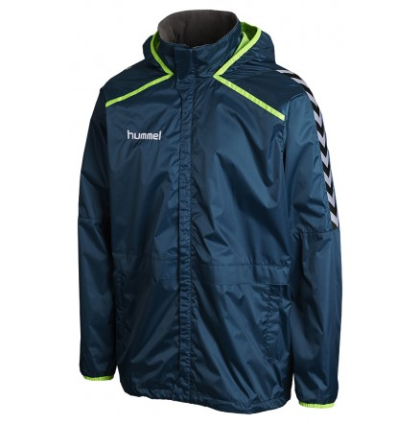
80 – 377 - 7511
STR | ANTAL
6/8
10/12
14/16
S
M
L
XL
XXL
MED HÆTTE

STAY AUTHENTIC POLY SWEAT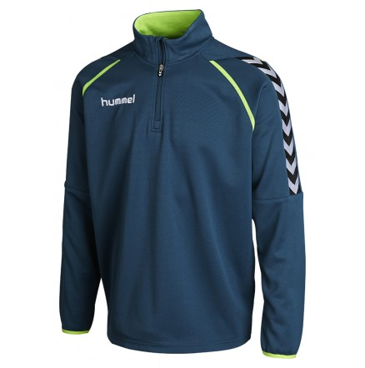
36 – 992 - 7511
STR | ANTAL
6/8
10/12
14/16
S
M
L
XL
XXL

STAY AUTHENTIC POLY SWEAT 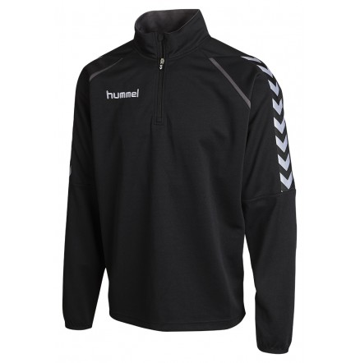
36 – 992 - 2001
STR | ANTAL
6/8
10/12
14/6
S
M
L
XL
XXL

Stay Authentic Windbreaker
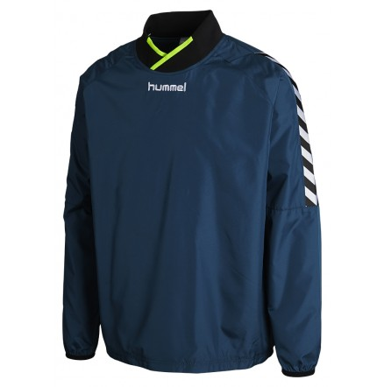
83 – 019 - 7511
STR | ANTAL
6
8
10
12
14
16
S
M
L
XL
XXL

Stay Authentic Windbreaker
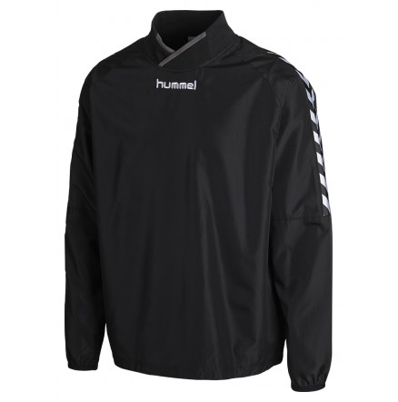
83 – 019 - 2001
STR | ANTAL
6
8
10
12
14
16
S
M
L
XL
XXL

Stay Authentic POLY Jacket
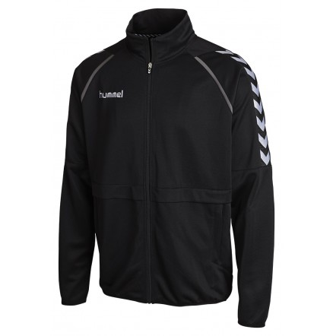
36 – 409 - 2001
STR | ANTAL
6
8
10
12
14
16
S
M
L
XL
XXL

Stay Authentic POLY Jacket
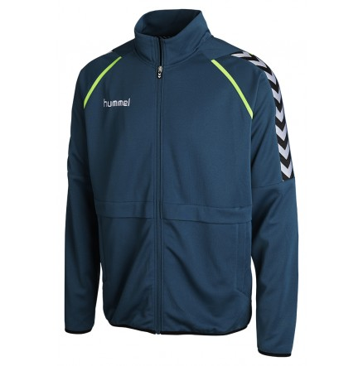
36 – 409 - 7511
STR | ANTAL
6
8
10
12
14
16
S
M
L
XL
XXL

Stay Authentic Poly Pants
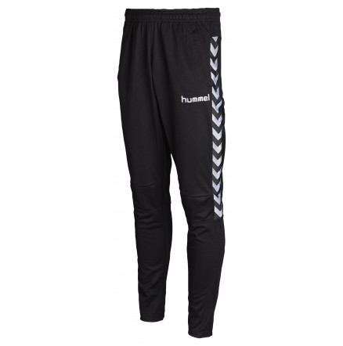
32 - 110 - 2001

STR | ANTAL
6
8
10
12
14
16
S
M
L
XL
XXL

Stay Authentic Football Pants
32-110-2001
STR | ANTAL
6/8
10/12
14/16
S
M
L
XL
XXL
SMALLE BEN

Stay Authentic Football Pants
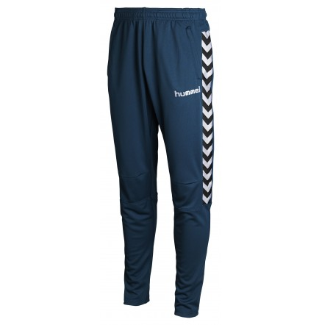
32-110-7511
STR | ANTAL
6/8
10/12
14/16
S
M
L
XL
XXL
SMALLE BEN

